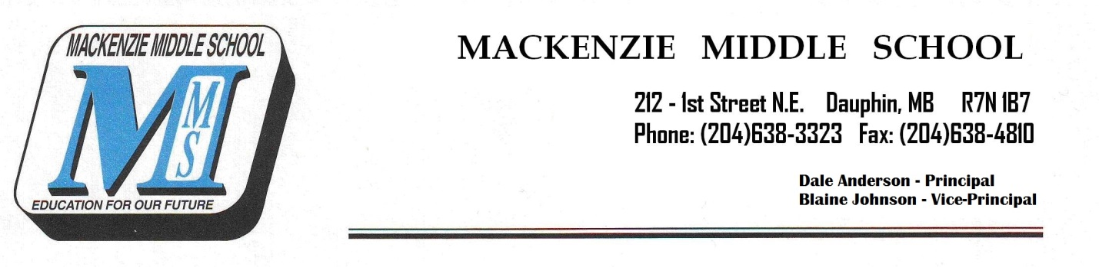
Dear Band Parent:
Mountain View School Division’s policy on the rental of school-owned instruments (including French horns, Euphoniums, Tubas, Bass Clarinets, and Baritone Saxophones) and/or the application of a user fee for the regular use of school owned percussion instruments is as follows:

- A Fee of $100.00 will be assessed to cover the costs of maintenance and future replacement of instruments. The fee is lower than average instrument rental prices because there is no purchase or “rent-to-own” option.

- Parent and child are responsible for instrument condition. Any necessary repairs due to mistreatment and/or lack of appropriate maintenance are the financial responsibility of the parent. Instruments must be returned in the same condition as they were issued.

Please note that in many cases these instruments cost between $1000.00-$5500.00 and are expected to last in excess of 10 years of regular use. Parents are expected to ensure their child fully understand the importance of proper instrument care (students receive instruction on proper instrument maintenance procedures in classes). Learning the responsibility of taking care of a musical instrument is one of the positive spin-offs of playing in band.
Please complete the form below and on the back of this page, and return it with your cheque (payable to Mountain View School Division) by September 30th, 2019.
I (parent/guardian) _______________________________ have read the above letter and agree to abide by the conditions contained therein.
Parent/Guardian Signature: ______________________________________
Student Signature: _____________________________________________
Date: ____________________________

